MCOR 30
TECHNICAL MANUAL

Prepared by G.E. Leyh 22 APR 03

Stanford Linear Accelerator Center
Power Conversion Dept
2575 Sand Hill Rd. MS #49
Menlo Park CA 94025

TABLE OF CONTENTS

- The MCOR Architecture
  - Overview
  - Crate and Backplane
  - Power Modules
  - Programming Card

- The MCOR30 Power Module
  - Overview
  - Theory Of Operation
    - Power Regulation and Filtering
    - Precision Output Current Measurement
    - Error Amplifier and PWM Controller
    - Interlocks and Diagnostics

- Service and Troubleshooting
  - Overview
  - Power Module Removal and Replacement
  - Diagnosing the MCOR30 Power Module

- Initial Testing and Calibration

- Specifications
  - Output Noise Waveform Measurements
  - Output Current Drift vs. Temperature
  - Output Current Step Response

ADDITIONAL DOCUMENTS
MCOR30 Schematic Diagram
1.0 THE MCOR ARCHITECTURE

1.1 Overview. The MCOR SERIES is a multi-channel corrector magnet driver system, capable of providing precision bi-polar output currents with minimal zero-crossover distortion. The MCOR design employs a modular architecture, consisting of a rack-mounted crate, with standardized slots for removable power modules, crate controller and diagnostics. A single, unregulated bulk power supply provides the main DC power for the entire crate.
A hinged, clear front cover provides access to the power modules and control card. The power module boards slide into standard card rails, and two locking extractor handles hold each module in place. All cards and power modules are accessible from the front of the crate. The crate is completely air-cooled, using standard rack mounted fans and plenums that draw in cool air from the aisle through a filter, then push the air up through the crate and into the rack, keeping the rack interior at positive pressure.
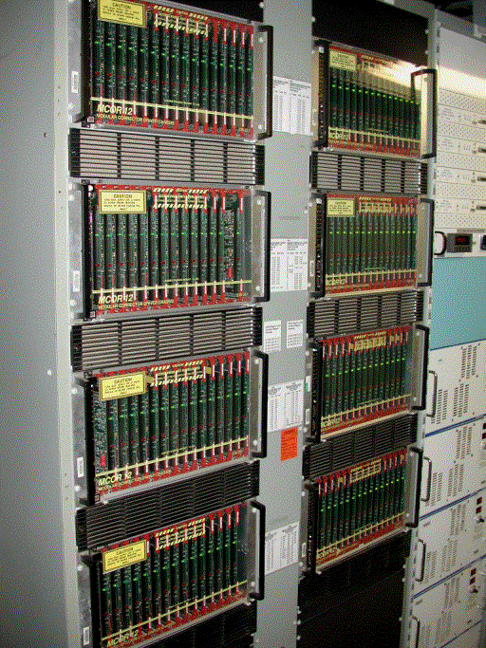

Figure 1.1. A typical MCOR installation
1.2 Crate and Backplane. A standard MCOR crate is shown in Figure 1.2. The MCOR crate consists of a standard 6U by 220-mm Eurocard subrack, a custom heavy-duty backplane and a rear connector panel. Each MCOR crate has 17 slots. The slot on the far left provides two 96-pin connectors for the control system interface card. The control card can have complex control circuitry onboard, or it can simply shuttle the control signals straight to and from the DAC/SAM connectors on the back of the crate. The slot for the control card offers access to connectors J1 (ExtIntlk), J2 (CrateOk), J3 (DAC), J4 (SAM), and J9 (Bitbus) on the rear of the crate, through the backplane. The end user typically designs the control card, to meet their individual control system requirements. The remaining slots (slots 0 thru 15) provide single 48-pin mixed-use connectors for the power regulation modules.
A 4-layer printed-circuit backplane provides all of the power and signal connectivity between the power modules, the control card and the outside world. A single unipolar bulk power supply provides the main DC power to the crate through an 180A Powerpole connector on the rear panel. This connector is attached internally to a pair of PC mount busbars that distribute the bulk DC power across the backplane. Copper traces on the backplane distribute the +5, +15 and -15 utility voltages to all the control and power modules in the crate. Each power module slot uses a single 48-pin DIN connector to provide both the signal and power connections, and the control card slot uses two 96-pin connectors. The lower 96-pin connector handles the commands and diagnostics to the power modules, and the upper connector deals with the crate and the outside world. No internal chassis wiring is needed except for the pigtail connector to the internal utility power supply. All other external connections, including the outputs to the magnets and the control system cables, are made through PC mounted connectors on the backplane.
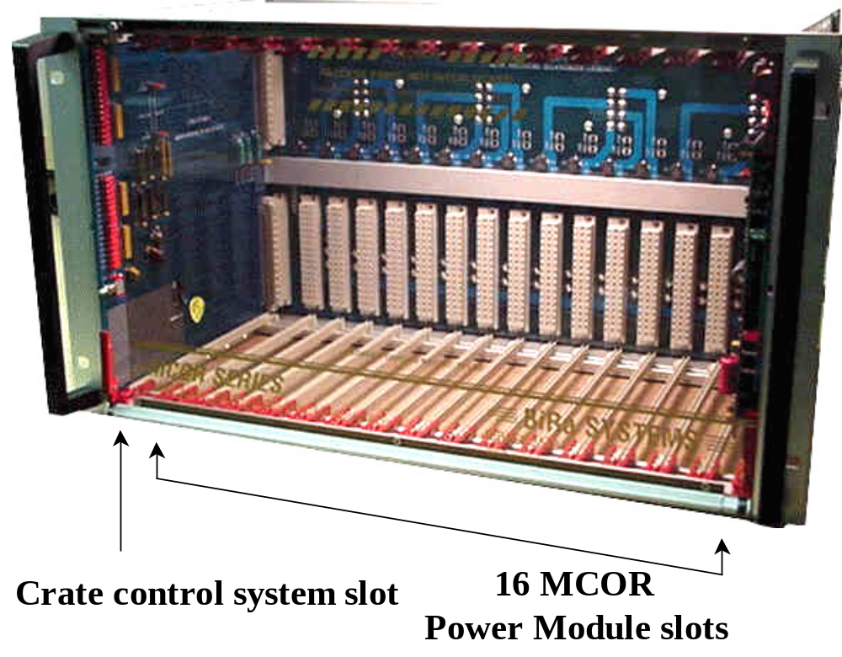

Figure 1.2. The MCOR Crate.
1.3 Power Modules. The MCOR power module is responsible for converting the unregulated DC bulk power into a precision bi-polar current source suitable for driving corrector magnets and beamline devices. The power modules are controlled using +10 to –10V FS analog command signals sent over the backplane from the control system. At the time of this writing there are two types of available MCOR power modules: The MCOR12 (12A FS) and the MCOR30 (30A FS). The MCOR12 uses a commercial switchmode servo driver (The AMC 30A8) operating in a voltage feedback mode to regulate the output current as shown in Figure 1.3. The 30A8 servo amplifier is bolted directly to the main PC board.
The MCOR30 uses a custom H-bridge configuration, operating in an overlapping volt-seconds feedback mode instead of a straight voltage mode to achieve a higher control bandwidth. A detailed description of the MCOR30 module operation can be found in Section 2.0.
The transfer function of input command voltage to output current is determined by resistor values on the programming (PGM) card (see 1.4). Each power module provides two independent measurements of its output current; one that closes the regulation loop, and another that returns an independent monitoring signal to the control system. Both of these independent current measurements are available to the control card for diagnostic purposes.
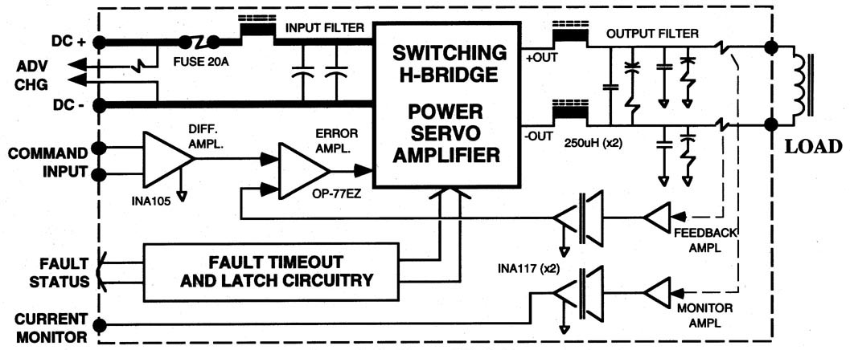

Figure 1.3. MCOR12 Block Diagram.

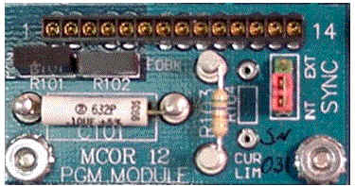
1.4 Programming (PGM) Card. In most installations the corrector magnet impedances and frequency characteristics will vary over a wide range. Each corrector installation will have its own unique cable plant resistance and maximum current rating, as well. All of these factors affect the stability and response time of the corrector. To provide a ‘custom-tailored’ response to each corrector magnet yet retain modularity in the driver design, each MCOR power module accommodates a small, removable programming (PGM) card, shown in Figure 1.4.

Figure 1.4. MCOR PGM Card.

The PGM card contains passive components that define several important characteristics of the corrector magnet and cable plant. The equations shown below assume a full-scale signal range of –10v to +10v.

• R102 -- Command voltage vs. output current R = 300,000 / full-scale output current

• R101 -- Output current vs. readback voltage R = 300,000 / full-scale output current

• R104 -- Maximum output current limit R = 3,000 ohm for 7.5A max output
(Note: The MCOR30 ignores this resistor) R = 20,000 ohm for 12A max output
R = OPEN CKT for 15A max output

• Tuning compensation values—C101 (pole), R103 (zero)

These scaling rules apply to both the MCOR12 and the MCOR30, so that the PGM cards are interchangeable between all MCOR power modules. When an MCOR power module is changed out, the PGM card is placed on the new module to retain the dynamic characteristics of that corrector magnet. Each PGM module typically has a ‘traveler’ -- a small label indicating the rack, crate and slot to which it belongs.
2.0 THE MCOR30 POWER MODULE

2.1 Overview. The MCOR30 power module is a second generation design, developed for the SPEAR III project at SLAC. The performance requirements for SPEARIII resulted in a fundamental re-design of the MCOR12 module, yielding higher output current (30A vs. 12A), higher operating voltage (65V vs. 50V), and improved dynamic performance (5.7kHz vs. 1.5kHz). The MCOR30 also offers features such as thermal protection for the output filter circuitry and voltage monitoring of both outputs.
The MCOR30 power module is two slots wide, to meet the connector current rating of standard MCOR crate format. A smaller ‘mezzanine’ board mounts over the precision shunts on the main board, and conducts half of the 30A output current capacity to the backplane through the adjacent 48-pin connector. Figure 2.1 illustrates the physical arrangement of the boards and power components. The mezzanine board supports the interlock and monitoring circuitry, and features LEDs visible from the front of the crate that indicate fault status and the presence of DC mains power.
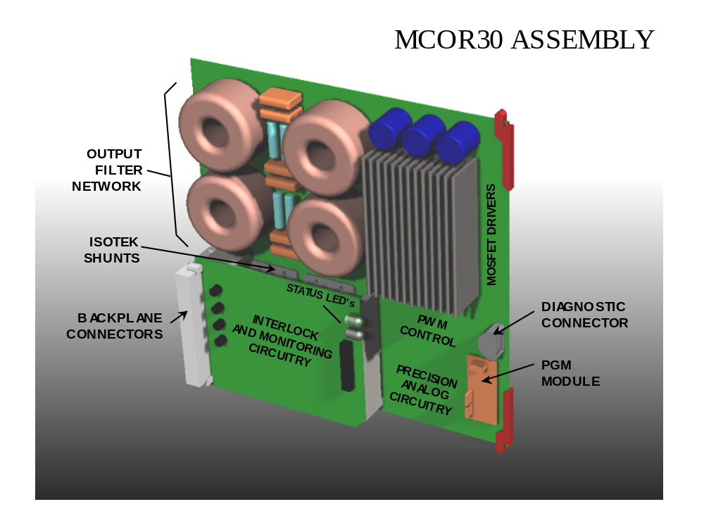

Figure 2.1. MCOR30 Physical Layout.

2.2 Theory Of Operation. The MCOR30 power module is a second-generation design, developed for the SPEAR III project at SLAC. The functional diagram of the MCOR30 is shown in Figure 2.2. The MCOR30 can be divided into four functional sections: Power regulation and filtering, precision current measurement, Error amplifier / PWM control and the diagnostic circuitry.
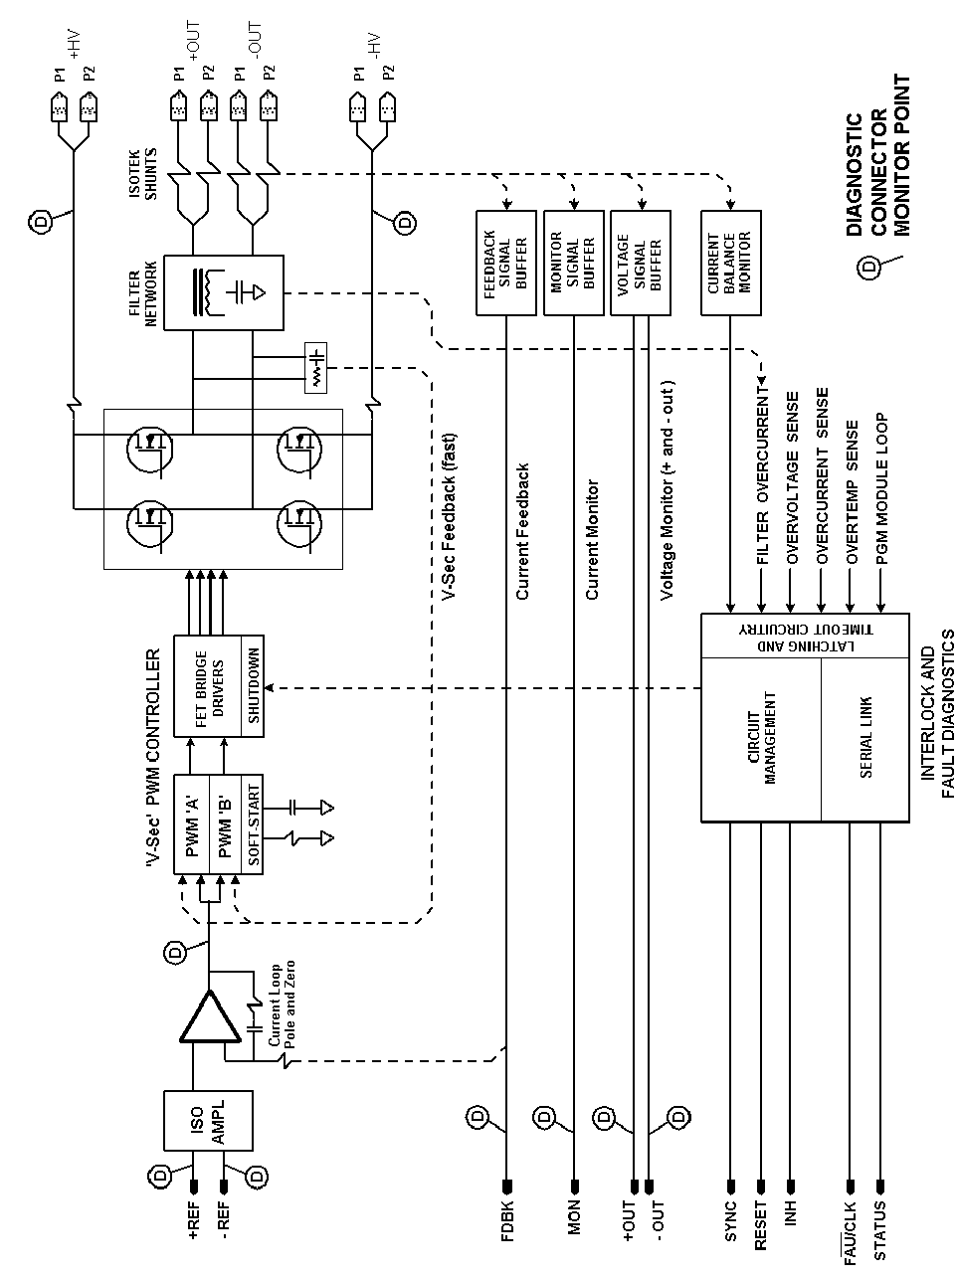

Figure 2.2. MCOR30 Block Diagram.
2.2.1 Power Regulation and Filtering. The MCOR30 regulates the DC output current by controlling the pulse width of an H-Bridge power MOSFET array as shown in Figure 2.2. The switching frequency is typically 40 to 60kHz. This particular H-Bridge design differs from the standard approach, in that each bridge leg has its own independent PWM controller. The H-Bridge shown here can actually be viewed as two independent buck converters. Each leg of the H-Bridge can operate at an independent duty cycle, between 0 and 100%. The output voltage of each leg is unipolar, yet the output current to the magnet is bipolar. Positive magnet current occurs when the positive output is driven and the negative output is clamped to ground, and negative magnet current occurs when the negative output is driven and the positive output is clamped to ground.
An important issue with standard H-Bridge PWM schemes is zero crossover distortion. Since the width of real pulses can’t smoothly drop to zero, the standard PWM circuit starts ‘pulse robbing’ as the magnet current nears zero -- effectively dropping the switching frequency. This results in a low frequency noise signature on the output when the magnet current is close to zero.
To solve this problem, the MCOR 30 controls each H-Bridge leg independently, allowing the pulse width of the active MOSFETs to be a small yet controllable value as the magnet current passes through zero. Figure 2.2.1 shows this relationship between the switching duty cycles and the magnet current.

100% DUTY CYCLE
FULL NEGATIVE
CURRENT
ZERO

STANDARD
H-BRIDGE

RED-POS OUTPUT
BLUE-NEG OUTPUT

FULL POSITIVE

CURRENT
100% DUTY CYCLE
FULL NEGATIVE
CURRENT
ZERO

MCOR30
H-BRIDGE

RED-POS OUTPUT
BLUE-NEG OUTPUT

FULL POSITIVE

CURRENT

Figure 2.2.1. MCOR30 PWM Transfer Function.
The filter network following the H-Bridge consists of two identical Praeg filters, one in each output leg. The twin filters are critically damped, with a cutoff frequency of around 8kHz. Two 200uH toroidal inductors in parallel make up the inductive element of each filter, so that a manageable wire gauge can be used to carry the 30A DC current. The capacitive element of the filter consists of three 1u SMT capacitors in parallel, located under the heatsink. Resistors R5 and R6 provide damping and minimize the loop response peaking at the filter’s resonant frequency. These two damping resistors have thermal interlocks (U20, U21) for protection against severe oscillations or voltage excursions.
2.2.2 Precision Output Current Measurement. Following the filter stage are four precision 4-terminal Kelvin connection Manganin shunt resistors (R1 through R4). These 10 milliohm shunts (Isabellenhutte A-H1 series) have an absolute tolerance of 0.1%, and a temperature stability of 13 ppm/°C typical. As shown in the schematic, two shunts in parallel measure the current in each output leg. This parallel-shunt arrangement offers several advantages:
- Absolute tolerance improves by 1.414
- Allows use of existing MCOR12 shunts, which have a known performance history
- Reduces inventory for a critical and expensive component
- Parallel shunts improve current sharing between the parallel output connectors
Precision 300ohm resistor arrays (R21 - R24) average the voltage readings from each shunt pair, and deliver the signal to floating amplifier stages U2 and U3. These precision amplifiers set the full-scale current and readback calibration using R101 and R102 (on the PGM card) as an absolute reference. The high common-mode unity gain differential amplifiers U7 and U8 translate the amplified shunt signals to ground potential. One shunt signal is fed back to the error amplifier, while the other is sent back to the control system as a redundant current monitor signal.
2.2.3 Error Amplifier and PWM Controller. The unity gain differential amplifier (U1) receives and isolates the analog command signal from the control system. The high common-mode rejection of U1 prevents input ground loops and rejects common-mode noise. This laser-trimmed differential amplifier offers a typical gain tolerance of 0.01%, a CMRR of 86dB and a gain stability of 1 ppm/°C. The error amplifier stage that follows (U9, OP77) compares the buffered command signal with the current feedback signal from U7 to produce an error voltage for the dual PWM controller circuits. A single pole-zero network (C101, R103 on the PGM card) provides frequency compensation for the precision control loop.
To produce the overlapping slope responses shown in Figure 2.2.1, two PWM management ICs (U15, U16) split the error signal and apply the necessary offsets and inversions. One of the PWM ICs (U16) generates the master clock at its SYNC pin. This clock frequency is set by C27 and R43, and controls the timing of the other PWM IC (U15) and the fast analog switch (U17).
As shown in Figure 2.2, there is a fast ‘volt-seconds’ feedback loop inside of the slower and more precise current feedback loop. This volt-seconds loop is an adaptation of the standard ‘current-mode’ control loop scheme. In switchmode power supplies with output filters, current-mode control can offer much faster transient response times than voltage-mode control, since current-mode operation can perform a ‘pulse-by-pulse’ regulation of the output filter current where voltage-mode operation must integrate the output voltage over the filter response time. Although current-mode schemes are faster, they more complex -- requiring a fast current measuring circuit floating at the voltage of the inductor. Standard current-mode regulators are prone to sub-harmonic oscillations and other instabilities as well, which in some cases are not solvable.
The MCOR30 design employs a custom variant of the standard current-mode topology which, for want of a better name, is termed a ‘volt-seconds’ control loop. In this scheme, the current in the inductor is dead reckoned by measuring the volt-seconds applied to it by the MOSFET bridge. Two RC integrators (C34,R48 and C35,R49) perform the volt-seconds measurement of the + and - output legs, respectively. Before the start of each pulse, U17 resets the capacitor voltage to zero. During the pulse the capacitor voltage ramps at a rate determined by the R and the measured voltage, integrating the applied volt-seconds until it crosses a threshold determined by the PWM IC and the error voltage. At this point the active MOSFET is switched off, and U17 rapidly discharges the integrating capacitor before the beginning of the next pulse.
The volt-seconds scheme improves the control bandwidth by removing the effects of the filter inductor on the control loop. The rejection of voltage noise on the DC mains is improved as well, since the volt-seconds applied to the inductor is regulated on a pulse-by-pulse basis.
Each PWM IC generates an open collector output signal that controls the MOSFET bridge controller IC, U14. This controller IC, the HIP4081A, performs several functions. Input logic interlocks prevent all four MOSFETs from simultaneously firing, and a deadtime control circuit prevents ‘shoot-through’ currents in the power MOSFETs. The deadtime is programmed by R37 and R38. The HIP4081 provides four independent MOSFET gate drivers; two floating and two that are ground referenced. Internal circuitry translates the logic levels and supplies isolated power to the floating gate drivers.

2.2.4 Interlocks and Diagnostics. A number of operating conditions are monitored continuously by the on-board interlock circuitry. Some of these interlocks are set to cause an immediate trip, where others such as the thermal interlocks feature a time delay. Below is a summary of the interlock functions:
- Overcurrent, Output -- Monitored by comparators U12 and U13. Trips when the current in either output exceeds the full-scale current rating by more than 15%. Initiates a fast shutdown of the MOSFET bridge. This interlock is latched by U204B until an external RESET pulse is issued.
- Overvoltage, DC Input -- Monitored by comparator U204A on the mezzanine card. Trips when the DC mains voltage exceeds 65V. Initiates a fast shutdown of the MOSFET bridge. This interlock is latched by U204B until an external RESET pulse is issued.
- Overtemp, Heatsink -- Monitored by temperature sensor U19. Trips when the heatsink temperature exceeds approximately 70C. Initiates a slow shutdown of the MOSFET bridge. This interlock is latched by U204B until an external RESET pulse is issued.
- Overtemp, Filter -- Monitored by temperature sensors U20 and U21. Trips when the temperature of R5 or R6 exceeds approximately 70C. Initiates a slow shutdown of the MOSFET bridge. This interlock is latched by U204B until an external RESET pulse is issued.
- Imbalance, Output Current -- Monitored by comparators U10 and U11. Trips when the current imbalance between the shunts in any shunt pair exceeds 15A. Initiates a slow shutdown of the MOSFET bridge. This interlock is latched by U204B until an external RESET pulse is issued.
- Missing PGM Card -- Monitored by U201A on the mezzanine card. Inhibits the MOSFET bridge driver if no PGM module is present. This interlock is not latched.
- External Inhibit Command -- Monitored by U201C on the mezzanine card. Inhibits the MOSFET bridge driver if the INHIBIT signal from the backplane is TTL high. This interlock is not latched.

The interlock steering logic on the mezzanine card provides a single fault summary of the interlock functions listed above. During a fault condition the interlock circuitry inhibits the MOSFET bridge, sends a high TTL logic fault signal to the control system and lights a red LED visible from the front of the crate.
The MCOR30 diagnostic monitor port is located near the front edge of the card. This 16-pin ribbon connector provides convenient access to a number of key voltage nodes for the purpose of in-situ diagnostics. Figure 2.2.4 shows the pinout of the diagnostic monitor port:

1 | 3 | 5 | 7 | 9 | 11 | 13 | 15
2 | 4 | 6 | 8 | 10 | 12 | 14 | 16
MONITOR PORT

- +INPUT COMMAND VOLTAGE (-10 TO +10)
- - INPUT COMMAND VOLTAGE (-10 TO +10)
- ERROR OUTPUT SIGNAL (U9-6, -10 TO +10)
- FEEDBACK SHUNT SIGNAL (-10 TO +10)
- -15v SUPPLY
- MONITOR SHUNT SIGNAL (-10 TO +10)
- +15v SUPPLY
- +5v SUPPLY
- SIGNAL GROUND
- POWER GROUND
- INHIBIT (TTL)
- +FILTER OUTPUT (47Kohm LIMIT)
- SYNC (TTL)
- - FILTER OUTPUT (47Kohm LIMIT)
- +12 ONBOARD SUPPLY (2K2ohm LIMIT)
- HVDC MAINS SUPPLY (47Kohm LIMIT)

Figure 2.2.4. MCOR30 Monitor Port Pinout.
3.0 SERVICE AND TROUBLESHOOTING

3.1 Overview. The driving principle behind the modular architecture of the MCOR corrector chassis is to minimize downtime of the machine. With over 1000 MCOR12 and MCOR30 units operating site-wide and beamtime costs of $10,000 per hour, a certain degree of ‘pit-stop mentality’ is essential to the overall design.
With this in mind, the main goal of any field repair effort should be to identify and replace the suspect module as quickly as possible. Any component level troubleshooting of the power module should be performed back at the shop. Crate level or magnet level diagnostics are necessary only if a new power module does not fix the problem, or if several modules in the same crate show a fault condition.
It is important to note that all MCOR30 power modules are identical and interchangeable. Only the plug-in PGM card on the power module determines the full-scale current rating. Each PGM card is associated with a certain slot, and is labeled with the building, rack, level and slot to which it belongs. When a power module is replaced, the programming card is removed from the old power module and installed on the new one to preserve the tailored response for the corrector magnet associated with that slot.

3.2 Power module Removal and Replacement. Each MCOR power module provides a fault summary LED visible from the front of the crate, identifying the module in trouble. This LED flashes red if the module has experienced any of the following interlock trips:
- Overcurrent, Output
- Overvoltage, DC Input
- Overtemp, Heatsink
- Overtemp, Filter
- Imbalance, Output Current
- Missing PGM Card
- External Inhibit Command
To remove the MCOR30 module from the crate:
- Shut down the DC bulk power supply and the 120 VAC utility power to the crate.
- Open the front cover by releasing the two front panel retaining screws. These screws release when pushed in with a screwdriver and turned 90 degrees CCW.
- Remove the power module, using the two extractor levers on the front of the card. As the card slides out the front of the crate, watch for interference with neighboring cards.
- Remove the Programming (PGM) card from the old power module and install it on the new module. The PGM card is fastened with two ¼” nuts. It is essential to place the PGM card back in its correct slot, as it contains critical tuning and calibration information for the corrector magnet it serves. A label on the PGM card identifies the building, rack, crate, and slot to which it belongs.
- Install the new power module, using the two extractor levers to lock the card into place. As the card is inserted, watch for interference with neighboring cards.
- Once all of the power modules are secure, re-apply the 120 VAC utility power then the DC bulk supply power. Press the manual reset button if the installation uses a DAC/SAM control card.
3.3 Diagnosing the MCOR30 Power Module. To repair the MCOR30 module in the shop, use the single MCOR module test stand, shown in Figure 3.2. This stand accommodates MCOR12 or MCOR30 modules, and provides the DC bulk supply, utility voltages, a variable command input voltage (MANUAL REF) and a large air-cooled test load. See Section 2.2 for a detailed theory of operation for the module. A suggested troubleshooting task flow is shown here:

[Step 1] CHECK DC SUPPLY CURRENT WITH INHIBIT
- Insure that PGM module and Mezzanine card are installed on the MCOR30 module.
- Turn off control power and bulk power supply before inserting MCOR module.
- CONTROL POWER -- ON
- MANUAL REF KNOB -- SET TO ZERO (GREEN LED ON)
- Verify that the red FAULT LED is flashing before turning on DC bulk supply.
- DC BULK POWER -- ON, SET TO 45 VOLTS
- The bulk DC supply current can be read off the front panel meter of the supply. If the DC supply draw is greater than 0.1A turn off the bulk supply and locate the cause of the current draw. Check for shorted power MOSFETs, driver ICs, or the +12 buck regulator. If the DC supply draw is less than 0.1A, proceed to the next step.

[Step 2] CHECK DC SUPPLY CURRENT AT IDLE
- MANUAL REF KNOB -- SET TO ZERO (GREEN LED ON)
- Press the red FAULT RESET button to clear the inhibit. If the DC supply current suddenly jumps to a high value (1A or greater), turn off the supply and proceed to Step 5.
- If the idle DC supply current falls in the range of 0.2A to 0.5A, proceed to Step 4.
- If the idle DC supply stays at 0.1A or less, proceed to the next step.

[Step 3] VERIFY PWM SYNC WAVEFORM
- Measure the SYNC waveform on the Diagnostic Connector Pin 13, or at U16-10. The pulse should be at least 3V tall, 500nS wide, and have a frequency of 40 to 50kHz.
- If the sync pulse appears normal, proceed to Step 5.
- If the sync signal is short or missing, troubleshoot the PWM circuit U15, U16 and U17. First check for proper +12v power supplied by the buck regulator U18. Next, try replacing U17, then U16 and U15. Once the sync signal is established, proceed to the next step.

[Step 4] RANGE THE MCOR30, CHECK FOR INSTABILITY
- CONTROL POWER -- ON
- MANUAL REF KNOB -- SET TO ZERO (GREEN LED ON)
- DC BULK POWER -- ON, SET TO 45 VOLTS
- Press the red FAULT RESET button to clear the inhibit. If the DC supply current suddenly jumps to a high value (1A or greater), turn off the supply and proceed to the next step.
- While viewing the IMON output with a scope, gradually increase the MANUAL REF knob to its full positive range (CW) then back through zero to full its full negative range, then back to zero. Look for oscillations or other instabilities with the scope while ranging the MANUAL REF knob. If the operation appears sound, proceed to the INITIAL TESTING AND CALIBRATION PROCEDURE in Section 4.0. If oscillation or instability is observed, proceed to the next step.
[Step 5] OPEN CONTROL LOOP TESTING
An effective way to troubleshoot a closed-loop system is to open the loop, thus allowing all the circuit stages in the loop to be treated as a single line of amplifiers, regulators and filters. On the MCOR30 this is accomplished by adding two 1k 1% resistors to U1 and U9:
First resistor between U1-6 and U9-2
Second resistor between U9-2 and U9-6
A pair of 8-pin IC clips with the resistors pre-attached are included as part of the test stand. If they are missing, they should be rebuilt. Any other reliable means of attaching the resistors will do, as well. Once the resistors are in place, turn on the power as follows:
- CONTROL POWER -- ON
- MANUAL REF KNOB -- SET TO ZERO (GREEN LED ON)
- DC BULK POWER -- ON, SET TO 0 VOLTS
- Press the red FAULT RESET button to clear the inhibit.
- Slowly ramp the DC supply to 30 volts, making sure that the DC supply current remains under 1A. If the current exceeds 1A, back off the voltage until the current is 1A. Determine the cause of the current before proceeding.
- 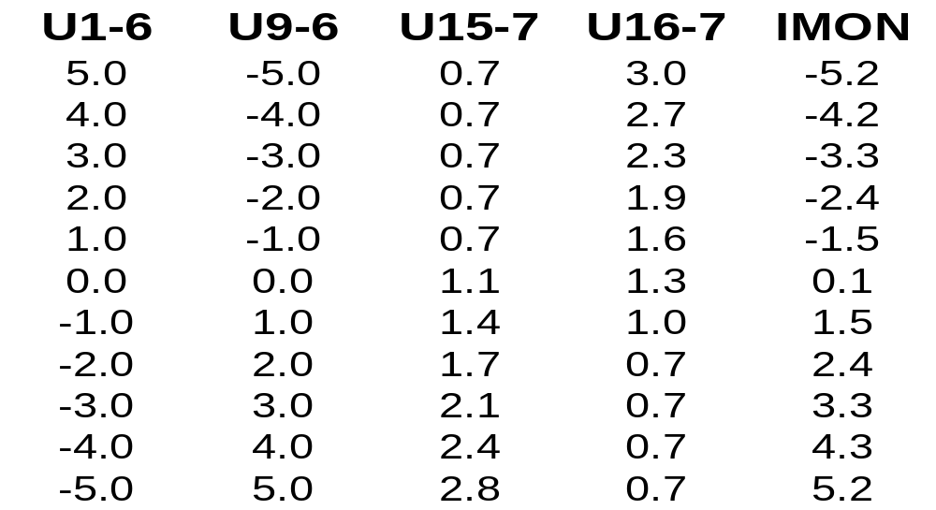Gradually turn the MANUAL REF knob CCW until the voltage at U1-6 measures +1.0V. Verify that the voltage readings in this chart vaguely match those of the circuit:

If the voltages at +1.0V check out, verify circuit operation at the other voltages by adjusting the MANUAL REF knob. The 1k loop-breaking resistors turn U9 into an inverting amplifier with a gain of -1. This should be seen in the relationship between U1-6 and U9-6.
The precision resistor networks at the inputs of U15 and U16 provide the dual-slope relationship shown in Figure 2.2.1. This should be seen in the voltages at U15-7 and U16-7, which program the duty cycle of each volt-seconds PWM controller, respectively.
If any of the voltages are off by a considerable amount, isolate the circuit just preceding the erroneous voltage measurement and determine the cause.
Once the circuit appears to be operating properly, remove the 1% test resistors and return to Step 4. Verify that the components on the PGM card have the correct values and are in good condition.

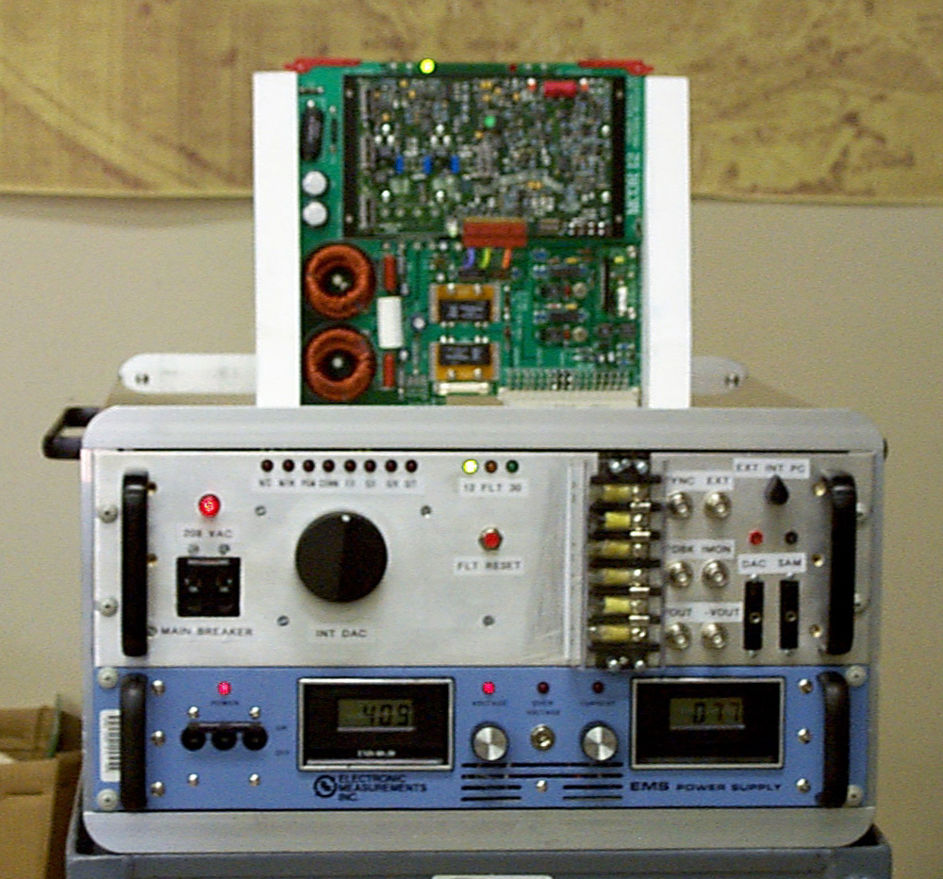

Figure 3.2. The MCOR30 Single-Board Test Stand.

4.0 MCOR 30 INITIAL TESTING AND CALIBRATION PROCEDURE

This setup procedure is for initial power up and testing of new or recently repaired MCOR 30 power modules. Use the MCOR test fixture shown in Figure 3.2 for this procedure.

The objectives of this procedure are to:
Check for obvious circuit malfunctions.
Insure that the feedback loop is stable over the operating range.
Verify the proper operation of the on-board interlock circuits.
INITIAL CHECKOUT PROCEDURE
- Insure that PGM module and Mezzanine card are installed on the MCOR.
- Turn off control power and bulk power supply before inserting MCOR module.
- CONTROL POWER -- ON
- MANUAL REF KNOB -- SET TO ZERO (GREEN LED ON)
- Verify that the red FAULT LED is flashing before turning on DC bulk supply.
- DC BULK POWER -- ON, SET TO 60 VOLTS
- Check that the bulk DC supply draw is no more than 0.4A.
- Press the red FAULT RESET button while monitoring the MON and FDBK waveforms with a scope. If the output oscillates, check for a loose or defective PGM module. If the power module still oscillates, reject it.
- Check that the bulk DC supply draw is no more than 0.4A. Nulling of the MANUAL REF KNOB may be required.
- Turn MANUAL REF KNOB ccw, ramping the output to its full negative range. Check the MON and FDBK waveforms for oscillations or other anomalies while ramping. Confirm proper operation at –30A.
- Turn MANUAL REF KNOB cw, ramping the output through zero to its full positive range. Check the MON and FDBK waveforms for oscillations or other anomalies while ramping. Confirm proper operation at 30A.
- MANUAL REF KNOB -- SET OUTPUT TO 20A
- OverCurrent Trip. Momentarily short the (+)output to ground. The short should trip the fault circuit. Press FAULT RESET to continue.
- OutputBalance Trip. Momentarily interrupt each of the four output branches, in turn. Each interruption should trip the fault circuit. Press FAULT RESET to clear each trip.
- OverTemp Trip. Measure Pin 5 of U19, U20 and U21 (TMP01). Check that the voltage is between 1.50 and 1.75 volts on each. Momentarily short pins 2 and 3 on each IC in turn. Each short should trip the fault circuit. Press FAULT RESET to clear each trip.
- Remove module and install in the test crate for DVIG certification. Use the MCOR30 TEST STAND pictured in Figure 4.0 to obtain the DVIG certification.

NOTE: An MCOR power module without a certified DVIG figure from the testing crate is not suitable for use in any commissioned installation.

THIS PAGE IS NOT VALID IF MODIFIED IN ANY FORM.
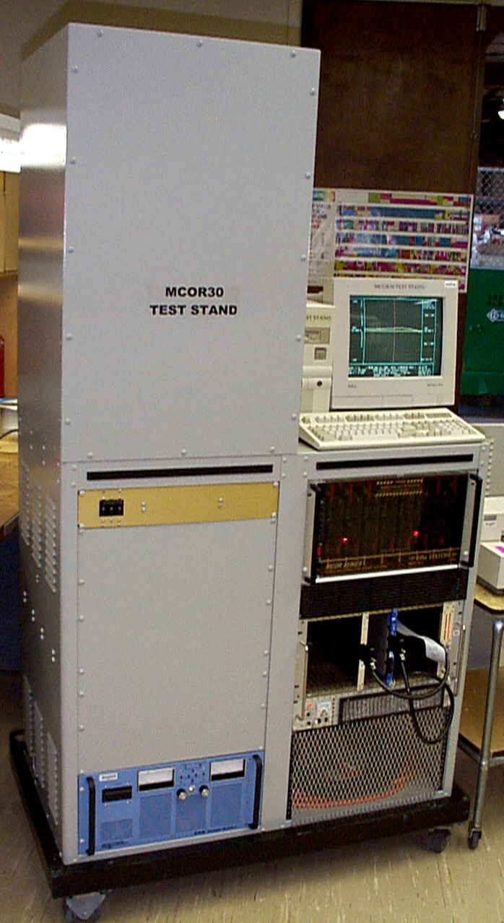

Figure 4.0. The MCOR30 DVIG Test Stand.
5.0 PERFORMANCE SPECIFICATIONS

PARAMETER | CONDITIONS | MIN | TYP | MAX | UNITS
HVDC SUPPLY BUS
Operating Voltage Range |  | 10 |  | 65 | V
Noise Injected onto HVDC Bus: | V_{hvdc} = 50V, I_{out} = 5A |  | 0.1 |  | Vrms
OUTPUT
Output Current Range |  | -30 |  | 30 | A
Output Compliance Voltage Range |  |  | 90% of DC mains
Initial Output Offset: | V_{hvdc} = 50V, V_{ref} = 0V |  | 1 |  | mA
Output Voltage Ripple: | V_{hvdc} = 50V, I_{out} = 5A |  | 0.4 |  | Vrms
Output Current Noise
0A Output, DC to 60Hz | V_{hvdc} = 50V, Load = 2ohm + 6mH |  | 20 |  | uArms
15A Output, DC to 60Hz | V_{hvdc} = 50V, Load = 2ohm + 6mH |  | 50 |  | uArms
REFERENCE INPUT
Impedance | Differential |  | 50 |  | k ohm
 | Common-Mode |  | 50 |  | k ohm
Voltage Range | Differential | -10 |  | 10 | V
 | Common-Mode | -20 |  | 20 | V
Common-Mode Rejection | Z_{source} = 0ohm | 80 | 90 |  | dB
Transfer Ratio |  |  | I_{out} = V_{ref} * 3oooo/R₁₀₂
Accuracy | 25°C ambient |  | 0.05 | 0.1 | %
vs. Temperature | 10 to 25°C ambient |  | 14 |  | ppm/°C
Vs. Temperature | 25 to 50°C ambient |  | 7 |  | ppm/°C
HVDC Supply Rejection (DC): | V_{hvdc} = 50V, I_{out} = 5A, 1V step |  | 110 |  | dB
Channel Crosstalk Rejection (DC): | V_{hvdc} = 50V, 30A step in I_{out} |  | 120 |  | dB
Monitor Channel Output Noise
DC to 5kHz | V_{hvdc} = 50V, I_{out} = 0A |  | 0.02 |  | Vrms
DC to 100kHz | V_{hvdc} = 50V, I_{out} = 0A |  | 5 |  | Vrms
DYNAMIC RESPONSE
3dB Bandwidth, 1% FS amplitude | V_{hvdc} = 50V, Load = 2ohm + 0mH |  | 5.7 |  | kHz
Slew Rate Response
5A step in I_{out} | V_{hvdc} = 50V, Load = 2ohm + 6mH |  | 6700 |  | A/sec
5A step in I_{out} | V_{hvdc} = 65V, Load = 2ohm + 6mH |  | 9100 |  | A/sec
Settling Time, to 1%
5A step in I_{out} | V_{hvdc} = 50V, Load = 2ohm + 6mH |  | 1 |  | mS
1A step in I_{out} | V_{hvdc} = 50V, Load = 2ohm + 6mH |  | 0.75 |  | mS
5.1 Output Noise Waveforms.
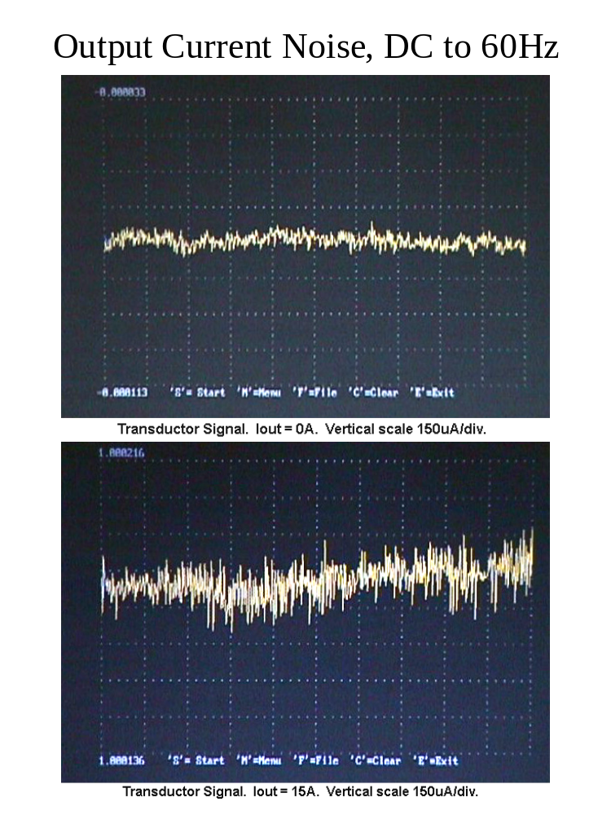

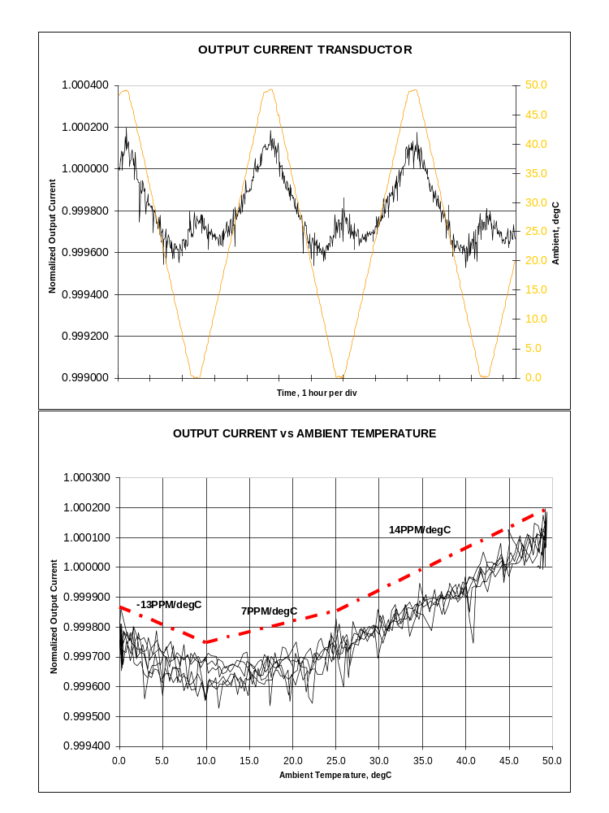
5.2 Output Current Drift Vs Temperature.

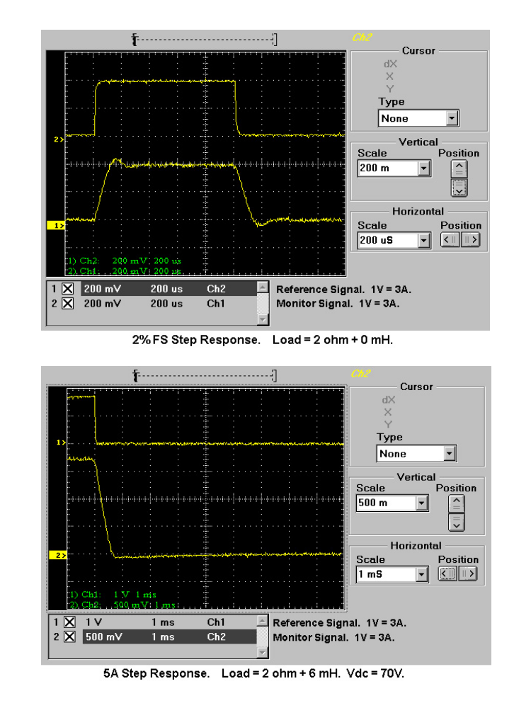
5.2 Output Current Step Response.

