Report No. ERC/NSM-B-00-20B

Development of Forming Processes for Copper Components for the Stanford Linear Accelerator

- Investigation of Potential Lubricant Contamination -

Phase II Progress Report

By

Dan Hannan, Graduate Research Associate

Gracious Ngaile, Staff Engineer

Dr. Taylan Altan, Professor & Director

November 2000



The Engineering Research Center
For Net Shape Manufacturing

Introduction
In cold forging, a lubricant is used to (a) reduce friction between the billet and the die, (b) allow forging of complex parts, and (c) increase die life that also reduces the forging cost. In certain cases, however, the lubricant may also have negative effects on producing a part. For example, a lubricant can inhibit the ability of a forged part to be welded. In other words, a lubricant can be damaging to the success of secondary operations that may be needed in subsequent processing and/or assembly operations.

This particular project entails the manufacture of copper components for the Stanford Linear Accelerator Center (SLAC) (this progress report focuses on Phase II of the project).

The contamination of the copper surface during forging needs to be evaluated because it could have a detrimental effect on final machining operations needed to obtain the final tolerances of the part. Also, if the surface of the copper component is contaminated by the lubrication it could be detrimental to the function of the component. The important factors in determining the effect of any lubricant contamination is how deep the contamination has penetrated the surface and what the composition of the lubricant is. For example, the presence of sulfur is a common element that is detrimental to many secondary operations.

Objectives
The objectives of Phase II of this study are to:
- Develop a testing procedure that will accurately simulate the conditions found in the actual forging of OFE copper (ring test & single cup backward extrusion test – see Figure 1)
- Using the developed tests, conduct experiments using at least two different lubricants that are common in the cold forging of copper components
- Evaluate the performance of the lubricants used for the experiments
- Evaluate the lubricant contamination on the surface of the copper specimens (chemical analysis to completed by SLAC)
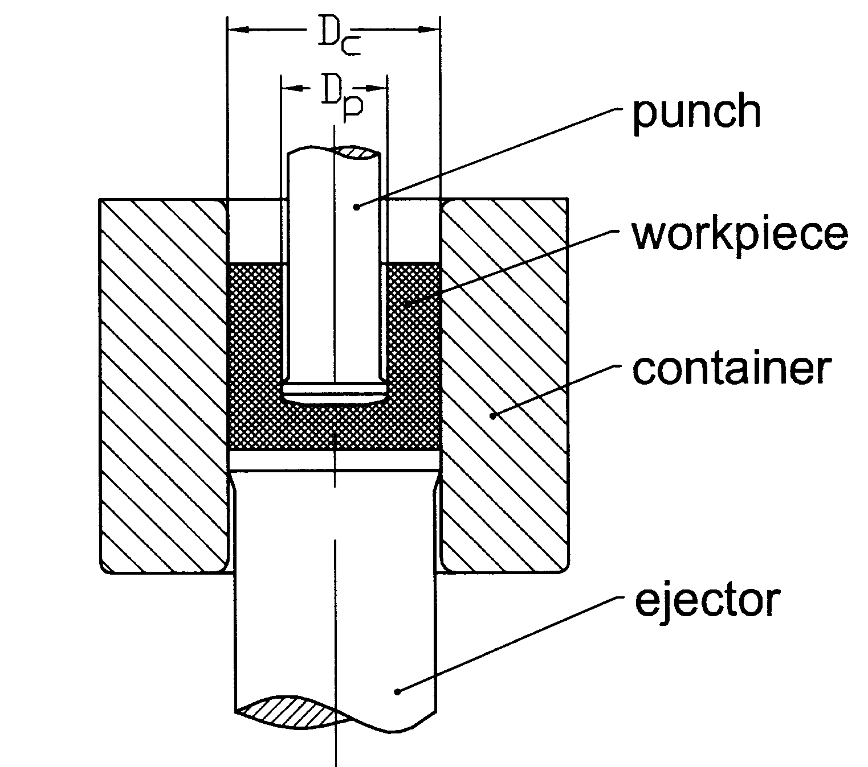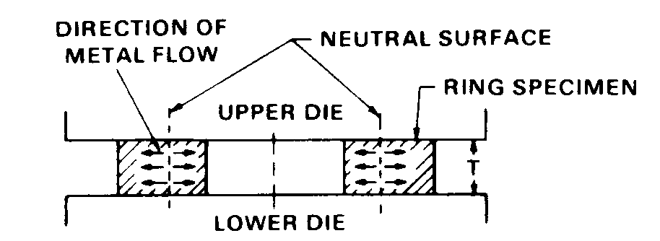
- (b)
Figure 1. a) Single cup backward extrusion and b) ring test (Altan 1983)

Approach
The experimental work for Phase II of the project consisted of a ring test and a single cup backward extrusion test. Each test was conducted using two different lubricants that are commonly used in the forging of copper.

After the single cup backward extrusion test the surfaces of the billets were investigated and compared. The same investigation was used after the ring test, but with this test the coefficient of friction was also estimated. This was accomplished by upsetting each material type to a different height reduction and then comparing the results to a set of calibration curves. This will be explained in detail later in this report.

After conducting the tests, the specimens were sent to SLAC so that the actual contamination of the lubricant (if any) could be determined.

Test Preparation

Manufacture of specimens
The geometry of the billet used for the ring test is shown in Figure 2a while the geometry of the billet used for the single cup backward extrusion test is shown in Figure 2b. The dimensions for each specimen were chosen based on specifications found in literature (Altan 1983).

SLAC was responsible for manufacturing the specimens to be used for the ring test and the single cup backward extrusion test. The number of specimens manufactured for each test is given below.
Ring Test
- 12 from bar, as received
- 12 from plate, as received
- 12 annealed (1025ºC for 15 minutes)

Single Cup Backward Extrusion
- 12 from bar, as received
- 12 from plate, as received
- 12 annealed (1025ºC for 15 minutes)
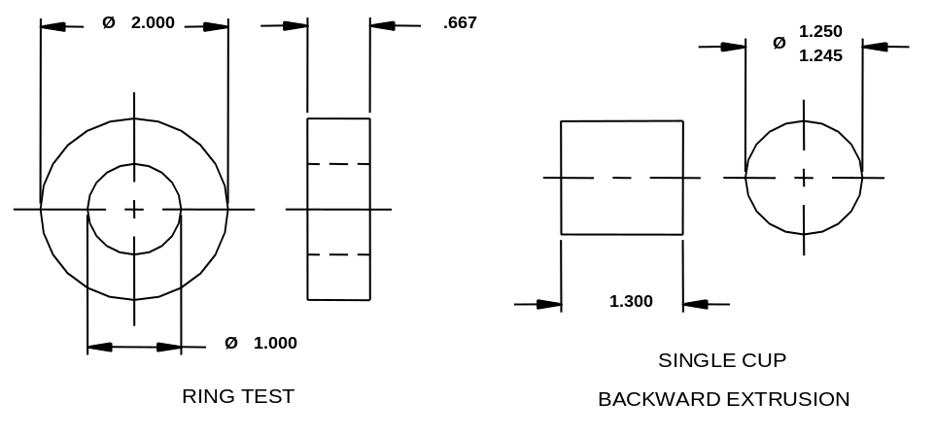
- (b)
Figure 2. Specimen geometry for the a) ring test and the b) single cup backward extrusion test

Tool and Data Acquisition Set-up

Tool Setup
The same tooling used to conduct the compression tests in Phase I was also used for the ring tests. To perform the single cup backward extrusion test, an existing ERC tooling was modified. This tooling is shown in Figure 3.

The tests were conducted in a Minster (160-DPA Tranemo) hydraulic press with a capacity of 160 tons

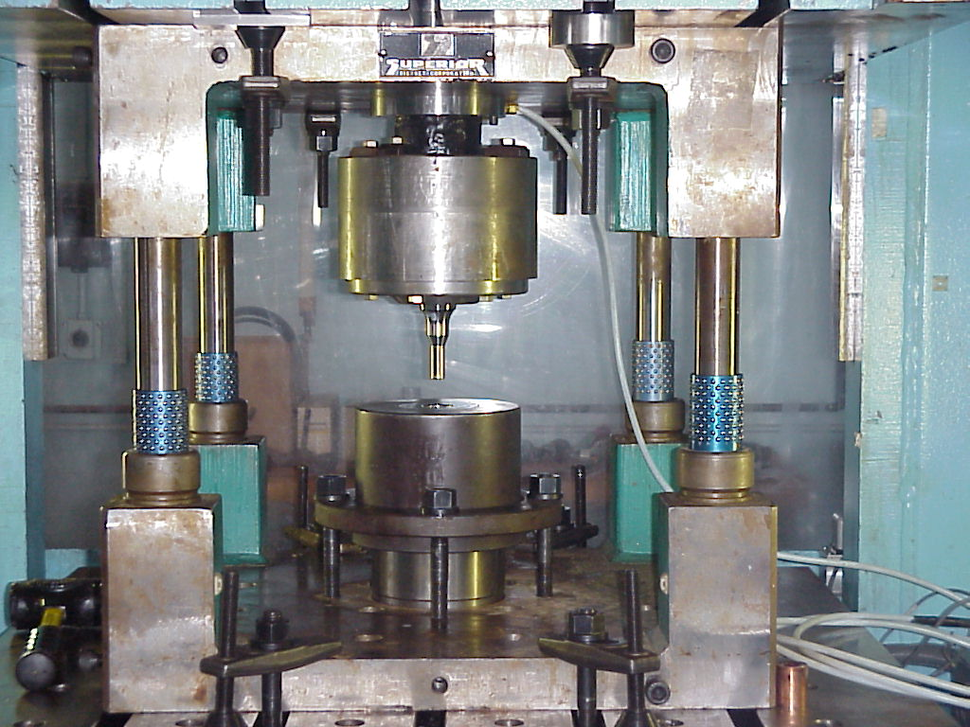
Figure 3. Single cup backward extrusion tooling

Data Acquisition
The data acquisition was used to record the load and stroke of the press during both the ring test and the single cup backward extrusion test. A displacement transducer was used to record the stroke, while a 50 ton Sensotec load cell was used to record the load. Both the load and the stroke were recorded in voltages so a conversion factor was found to obtain the load in lbf and the stroke in inches. The load cell was calibrated using Labview and a 59 kΩ shunt resistor as recommended by the manufacturer.

Specimen Preparation & Lubrication
To prepare the specimens for the tests, the dimensions of each billet were measured and recorded. The specimens were each placed in a separate bag and were labeled by number, material type, and the name of the lubricant to be used.

Two lubricants were chosen to be evaluated for each test. Each lubricant was brushed onto each designated billet just before testing. The dies and/or punches were also brushed with a light amount of lubricant. The name and general information for each of the two lubricants is shown below. More details about each lubricant can be found in the appendix. These particular lubricants were selected because they are commonly used for cold forging of copper to complex shapes. They were recommended by the Nippert Company, which manufactures numerous complex copper components by cold forging.

- Houghto-Draw 756-A (HD-756-A)
  - Diluted 3:1 with water
  - Oil free
  - No chlorine, no sulfur
  - Ferrous and non-ferrous

- Richard Apex HSDL-MW8EH
  - 8-12% concentration in water
  - No sulfur
  - Easily cleaned

Ring Test

Testing of Specimens
To complete the ring test experiments a total of 18 specimens were upset using the ring test tooling. The groups of specimens that were tested are given below:
- Group 1: 3 from bar, as received, lubricated with HD-756-A
- Group 2: 3 from plate, as received, lubricated with HD-756-A
- Group 3: 3 annealed lubricated with HD-756-A
- Group 4: 3 from bar, as received, lubricated with HSDL-MW8EH
- Group 5: 3 from plate, as received, lubricated with HSDL-MW8EH
- Group 6: 3 annealed lubricated with HSDL-MW8EH

Each of the three specimens in each group above was upset to a different height reduction (i.e. 20%, 30%, and 50%). Figure 4 shows an example of one group of specimens upset during the ring test experiments.

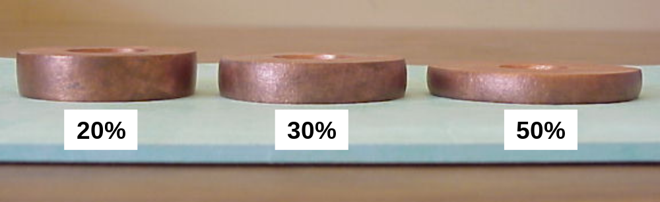
Figure 4. Copper from bar, as received, lubricated with HSDL-MW8EH

After upsetting a group of three specimens (each to a different height reduction, see Figure 4), the inner diameter (I.D.) and final height are measured and recorded. This data, along with the initial I.D. and height, will be used to plot three points onto a calibration curve similar to the one shown in Figure 5. The three points that form a curve represent an approximation of the coefficient of friction between the dies and specimen for a particular group given above (i.e. each group consists of a material type and the lubricant used). This allows us to compare the performance of the lubricants during the ring test experiments.

The calibration curves, like those seen in Figure 5, are found through FEM simulation. The ring test is simulated to each of the three reductions using different values of the shear friction factor, m, as seen in Figure 5. In determining the friction with the ring test, we consider the friction to be represented by

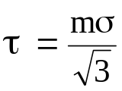 [1]
where
τ = friction shear stress
m = friction shear factor
σ = flow stress of the deforming material

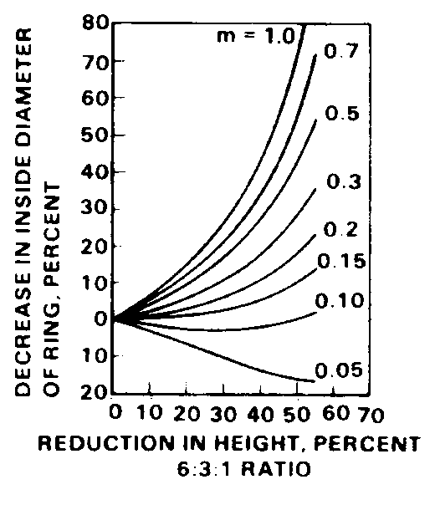
Figure 5. Example calibration curves used to approximate the coefficient of friction from data found during an experimental ring test [Altan, 1983]

Results

Shear Friction Factor
*Note: No results are given for the annealed specimens in this section because in Phase I the flow stress of the material could not be found due to non-uniform deformation and, therefore, the calibration curves could not be generated.

Figure 6 and Figure 7 show the experimental data plotted against the calibration curves for copper bar (as received) and copper plate (as received), respectively. The figures show that the two lubricants perform about the same, using the shear friction factor as the comparison. However, tests with copper bar specimens give slightly lower values of the shear friction factor. This difference is probably due to the way the specimens were manufactured. In fact, the copper bar specimens had larger grooves on the surface from the machining of the specimens (shown in next section) than the cooper plate specimens. This would allow the copper bar surface to hold more lubricant and also keep lubricant from being “run off” the surface, giving a slightly lower shear friction factor. Also, HD-756-A seems to be slightly better, at high reductions (50%), than HSDL-MW8EH.

For both lubricants the shear friction value (m-value) was found to be just under 0.3. Using the Coulomb law of friction, we obtain the friction shear stress, τ, as

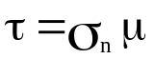 [2]
where
σ_{n} = normal stress at the billet-die interface
μ = coefficient of friction

In cases where the value of flow stress, 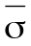, of equation 1 is approximately the same as the normal stress, σ_{n}, from equation 2, we have approximately a coefficient of friction of about μ = .17, by equation 3.

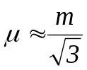 [3]
It must be noted, however, that these values only correspond to our particular tests and can only be used to compare lubricants. In other processes or tests the values could be different depending on the process conditions of the forging operation (i.e. billet material, surface finish of the die, temperature, die geometry, etc.)

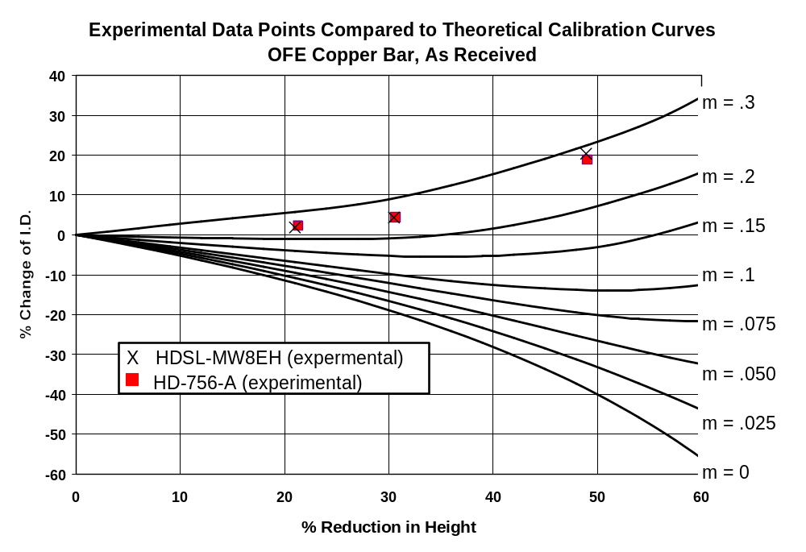
Figure 6. Experimental data plotted on calibration curves (for OFE copper bar, as received) (Size ratio = OD:ID:Thickness = 6:3:2)

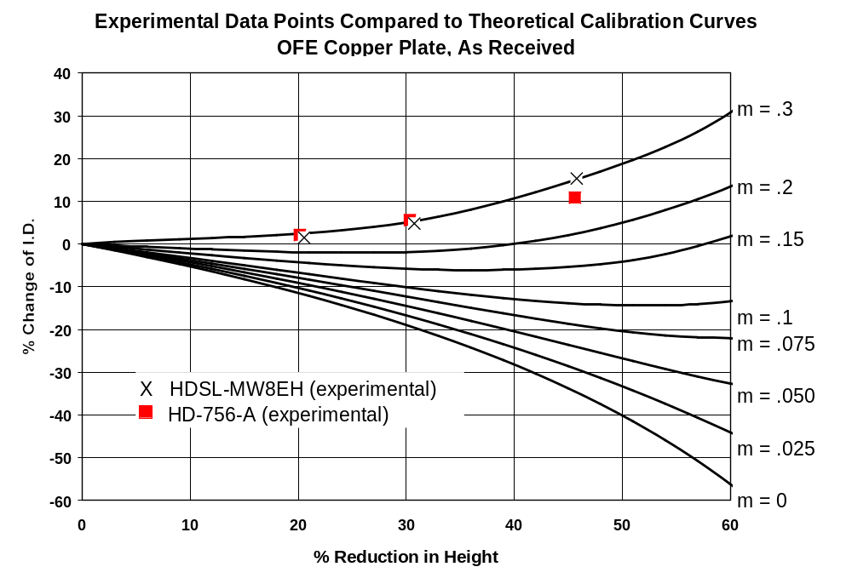
Figure 7. Experimental data plotted on calibration curves (for OFE copper plate, as received) (Size ratio = OD:ID:Thickness = 6:3:2)

Investigation of the Surface
Figure 8 shows the initial top surface of the ring test specimens for each copper material type (bar, plate, annealed). The photographs were taken with an optical microscope. Notice that there is a considerable difference between the three surfaces. For copper bar and copper plate the difference comes from the way the particular specimen was machined to its final dimensions. For the annealed specimen the difference is due to the grain growth during the annealing operation.

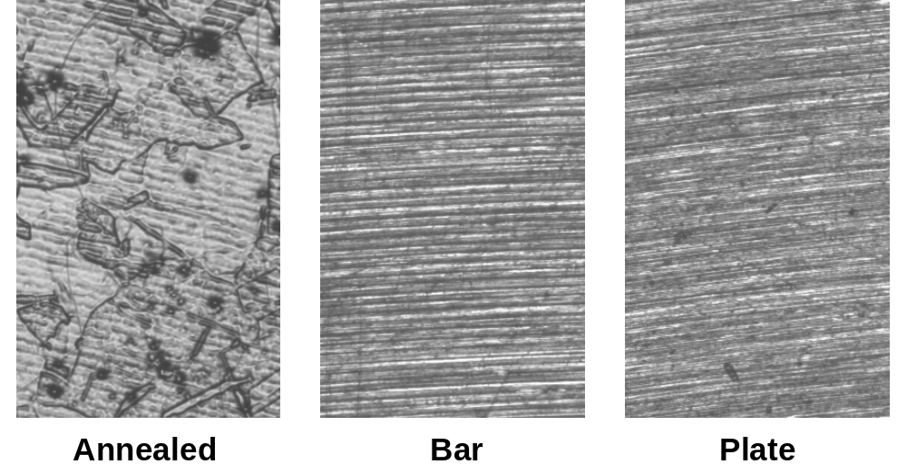
1 mm
(a) (b) (c)
Figure 8. Initial top surface of the ring test specimens for a) annealed copper, b) copper bar, as received, and c) copper plate as received. (~75X Magnification)

Before we look at the micrographs of the surface after deformation, one needs to understand what is happening on a macro scale. Figure 9 shows the top surface of the specimens after deformation to a height reduction of 30%. Notice that the copper bar specimen has a rougher surface than the copper plate specimen. This is due to the larger grooves found on the copper bar specimen after machining (see Figure 8). The annealed specimen has a very rough surface and there seem to be gouges in the surface similar to galling. This is due to the grain growth from the annealing operation. Also, as seen in the specimens used to test for flow stress, the copper bar specimen has the best uniform deformation (i.e. the inner and outer diameters of the specimen are round). Although hard to see in Figure 9, the copper plate specimen is not completely round and tries to form an oval shape.

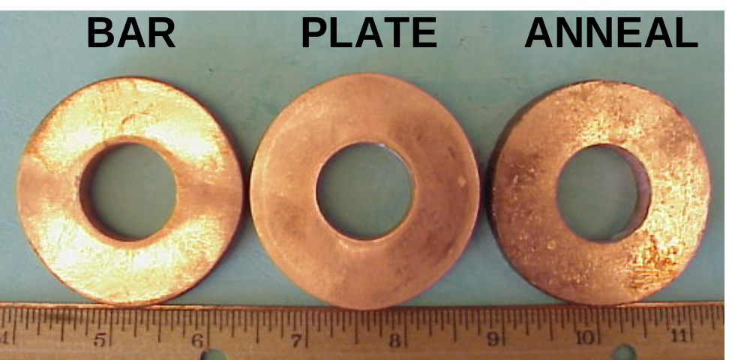
Figure 9. Top surface of copper specimens, after deformation to a height reduction of 30%.

Figure 10 shows micrographs of the top surface of the ring specimens after deformation to a height reduction of 50%. The top row of pictures (a-c) are of specimens lubricated with HD-756-A while the bottom row of pictures (d-f) are of specimens lubricated with HSDL-MW8EH. Comparing the micrographs gives the following conclusions:

- The lubricant HD-756-A was more effective at reducing scratches to the surface than HSDL-MW8EH
- The lubricant HD-756-A did not “thin out” as much as HSDL-MW8EH during deformation
- For copper bar, both lubricants produced gouges, or “galling like” features on the surface of the specimens
- Excessive gouges were found on the annealed specimens for both lubricants

(a) (b) (c)
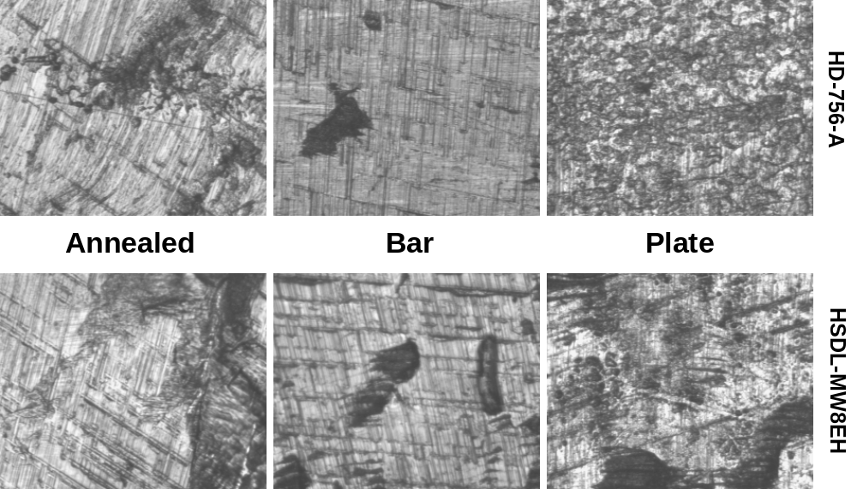
1 mm
(d) (e) (f)
Figure 10. Top surface of the ring test specimens after deformation to a 50% height reduction for a) annealed copper lubricated with HD-756-A b) copper bar lubricated with HD-756-A c) copper plate lubricated with HD-756-A d) annealed copper lubricated with HSDL-MW8EH e) copper bar lubricated with HSDL-MW8EH f) copper plate lubricated with HSDL-MW8EH. (~75X Magnification)

Lubricant Contamination (Chemical Analysis)
This part of the project is being completed by SLAC and the final results of these tests are not ready.

Single Cup Backward Extrusion

Testing of Specimens
To complete the single cup backward extrusion experiments a total of 18 specimens were tested using the tooling shown in Figure 3. The specimen geometry was shown previously in Figure 2b. The 18 specimens were divided into the following groups:
- Group 1: 3 from bar, as received, lubricated with HD-756-A
- Group 2: 3 from plate, as received, lubricated with HD-756-A
- Group 3: 2 annealed lubricated with HD-756-A
- Group 4: 3 from bar, as received, lubricated with HSDL-MW8EH
- Group 5: 3 from plate, as received, lubricated with HSDL-MW8EH
- Group 6: 2 annealed lubricated with HSDL-MW8EH
- Group 7: 1 from bar, as received, with no lubricant
- Group 8: 1 from plate, as received, with no lubricant
All specimens were deformed at a 25% reduction which is found using Equation 4.

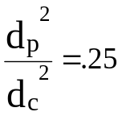 [4]
where
d_{p} = diameter of the punch
d_{c} = inner diameter of the container (or die)

Each specimen was deformed, or extruded, to give a cup height of about 1.100 inches. The cup height is the average distance from the top of the specimen to the bottom of the hole. After the experiments were conducted, the surface of the outer diameter (O.D.) of each specimen was investigated using an optical microscope.

Results

Investigation of the Surface
The single cup backward extrusion test does not permit a procedure similar to that of section 5.2.1. Consequently, one must rely on the surface of the specimens to evaluate the effectiveness of the lubricants. In most cases, one would investigate the O.D. surface and the inner surface of the cup for each specimen. However, to investigate the inner surface of the cup we would have to cut the pieces in half. It was decided that cutting the specimens in half may distort the results of the lubricant contamination test, which is the most important part of Phase II. In other words, for single cup backward extrusion, the O.D. surface of the specimens is the lone indicator of the effectiveness of each lubricant.

Figure 11 shows the outer surface of each copper material type for specimens after deformation lubricated with HD-756-A and specimens lubricated with HSDL-MW8EH. Also shown in Figure 11 is the outer surface of each copper material type without lubrication and before deformation. Notice that for copper bar the surface after deformation looks very similar to the surface before deformation, for both lubricants. However, for the copper plate specimens and the annealed specimens this is not the case. The difference is probably due to the way each material is processed and machined. The surface texture of the copper plate and annealed specimens was worse when HSDL-MW8EH was used.

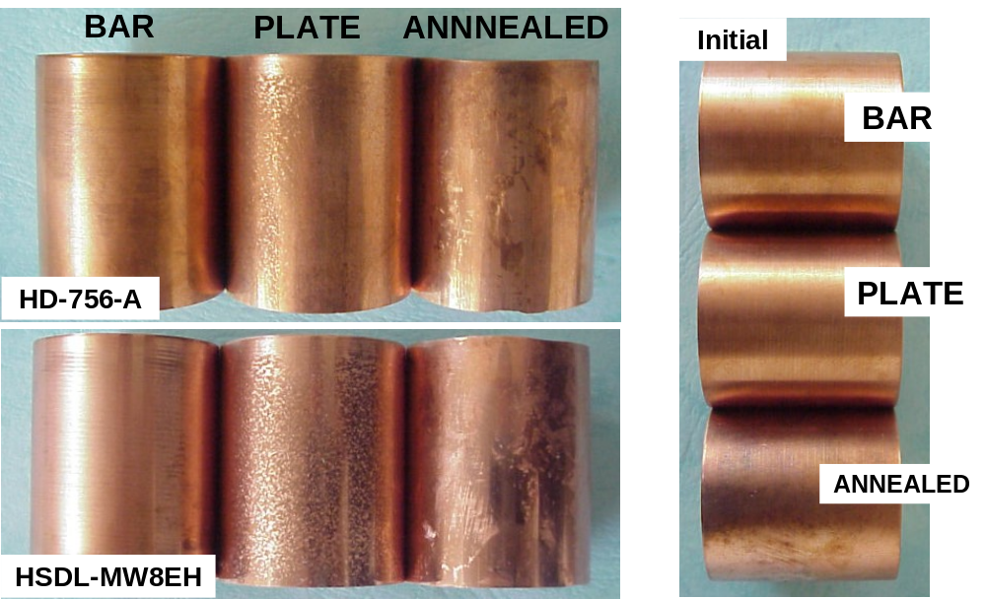
- (b)
Figure 11. The outer surface of the specimens a) after deformation, and b) before deformation

Figure 12 shows optical micrographs of the cylindrical surface of the specimens before deformation & without lubrication. Again, a difference between the three material types is clearly visible. Both the copper bar specimens and the plate specimens seem to be machined the same way. However, the copper bar specimens seem to have been machined “rougher” than the plate specimens. The annealed specimens again have the surface shown because of the grain growth during the annealing operations.
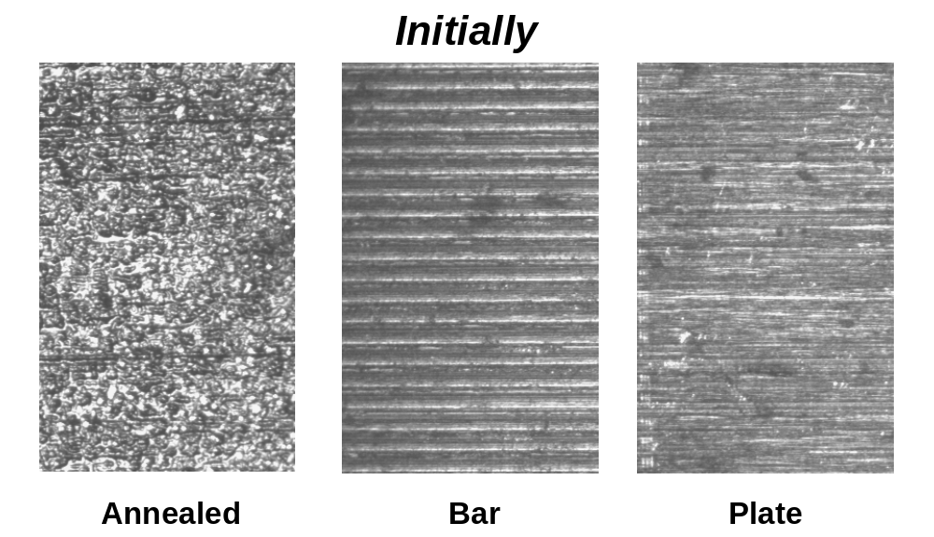
1 mm
Figure 12. Optical micrographs of the cylindrical surface of the specimens before deformation (~75X Magnification)

Figure 13 shows the outer surface of the specimens after deformation. Again, there is not much difference in the optical micrographs from one lubricant to the other, but HD-756-A does seem to perform slightly better (i.e. reducing scratches and “galling like” defects). The “grooves” seen in Figure 12 for copper bar are again seen in Figure 13. This is due to the extra lubricant that stays on the surface inside these grooves. For copper plate the “grooves” are smaller and, therefore, this effect is not seen. However, the surface of the plate specimens has gouges or “galling like” defects. The optical micrographs of the annealed specimens show many “galling like” defects because of the increase in grain size from the annealing operation.

(a) (b) (c)
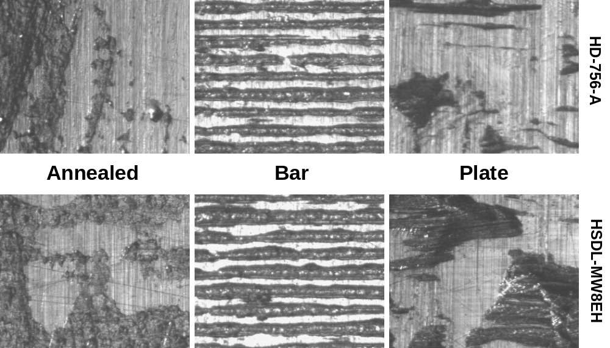
1 mm
(d) (e) (f)
Figure 13. Optical micrographs of the cylindrical surface after deformation for a) annealed copper lubricated with HD-756-A b) copper bar lubricated with HD-756-A c) copper plate lubricated with HD-756-A d) annealed copper lubricated with HSDL-MW8EH e) copper bar lubricated with HSDL-MW8EH f) copper plate lubricated with HSDL-MW8EH. (~75X Magnification)

Figure 14 shows the outer surface of a copper bar and copper plate specimen after deformation without lubrication. An annealed specimen without lubrication was not tested because we did not have enough of the annealed specimens left. Notice that the surfaces are different than those with lubrication. These surfaces have “deeper” scratches and more gouges. Of course, this is expected since there is no lubrication to protect against metal-to-metal contact between the die and the workpiece. Also, the surface of the copper bar specimen is worse than the copper plate specimen.
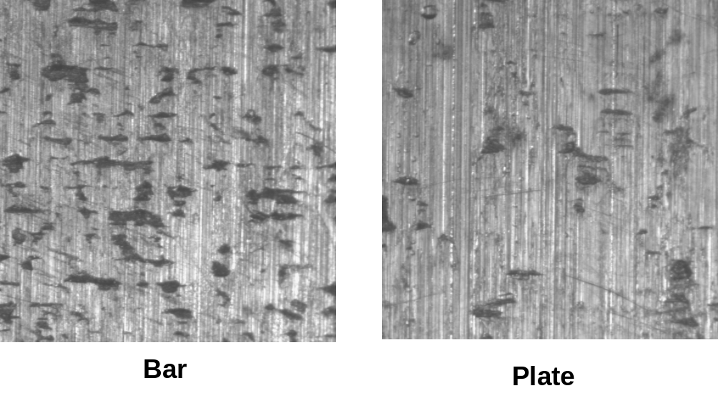
1.5 mm
Figure 14. Optical micrographs of the cylindrical surface after deformation without lubrication (~75X Magnification)

Lubricant Contamination (Chemical Analysis)
This part of the project is being completed by SLAC and the final results of these tests are not ready.

Conclusions
Although the main part of Phase II, which is the lubricant contamination analysis, has not been completed we can still make conclusions based on the optical micrographs and the shear friction factors obtained from the ring compression tests.

The lubricant HD-756-A performed better than HSDL-MW8EH (i.e. less scratches and “galling like” gouges on the surface of the specimens). However, this difference in the performance of the two lubricants was small. Also, the forging pressures obtained during these tests may not be as high as the forging pressures obtained in the actual forging of the copper components. Higher pressure could cause any of the two lubricants to perform better or worse. For example, for the ring test the forging pressure on the top die was approximately 65 ksi (50% height reduction) while the punch pressure encountered during the single cup backward extrusion test was approximately 117 ksi. These pressures are low compared to forging pressures of 300 ksi or higher, which are commonly encountered in closed die forging. However, it is believed, based on past work, that the tests conducted for Phase II give a good indication of what will be found during actual production runs.

The optical micrographs also show some possible problems for secondary operations. SLAC plans to use a diamond machining process to obtain the finish part dimensions for a particular copper component. The tolerances for these parts are very close (i.e. microns). Since many of the specimen surfaces have gouges or scratches, one must investigate whether they will effect the secondary operations. Basically, the scratches or gouges cannot be too deep into the surface (i.e. deeper than what is going to be machined off). If the scratches are found to be to deep, one must redesign the forging so that enough stock or material is left on the formed part so that all scratches and gouges are machined away during secondary operations.

Another thought about the scratches or gouges on the surface of the specimens is how they will effect the lubricant contamination, if any is found. Larger scratches or gouges will obviously allow the lubricant to contaminate the surface deeper causing problems in the manufacture of the copper component down the line. Therefore, this must also be looked into once the chemical contamination analysis is completed.

References
- Altan, T., Oh, S.I., and Gegel, H., (1983), Metal Forming-Fundamentals and Applications, American Society of Metals, Metals Park, Ohio.

Appendix

